Smart parkingExternal development interface

Catalogue
Smart parkingExternal development interface 1
One Get on-site fees 2
Two Lift the rod instruct 3
Three License plate issuance 5
Four Palpitate .7
Five License plate cancellation 8
Six Parking space inquiry 9
Seven Similar license plate query 11
VIII Obtain the admission record 13
Nine Get the appearance record 15
Ten GetCharge details .17
Eleven GetPictures of entry and exit 20
Twelve Payment is completed and issued 22
April Monthly Subscription Renewal 32

One Get On-site expenses
Get on-site fees
POST: http://192.168.1.169:9001/yard/third/getCentrilChargeData?CarNo=B98255
Request data type:application/json | Response data type:application/json

Interface description
Used for Consumer Check the expenses incurred by the vehicles in the field

Request Parameter
Parameter name | Parameter description | Type of request | Is it required | Data type
carNo | License plate number | Query | Yes | String

Response status
condition code | explain
200 | Request successful
Other status codes | Request failed, please contact:13066858850

Response parameters
Parameter name | Parameter description | Data type
status | Returned status code | Int
data | The specific data returned | String
carNumVo | Entry and Exit Record | Object
inTime | Entry time | Date
outTime | Appearance time | Date
payStartTime | Actual billing start time | Date
payEndTime | Actual billing end time | Date
carType | Vehicle type | Int
realCarType | Actual vehicle type | Int
status | 0 indicates normal billing, 1 indicates normal billing but no charge,  2 indicates abnormal, 3 - no charge required. | Int
carNo | License plate number | String
parkTime | Parking duration | Int
totalAmount | Receivable amount (Unit: Fen) | Int
disAmount | Discount amount (Unit: Fen) | Int
couponAmount | Actual Receipt Amount (Unit: Fen) | Int
payedPrice | Amount Paid | Int
small | 0 large parking lot, 1 small parking lot | Int
isSwitchCoupon | Do you want to switch the discount coupon (1: No, 2: Yes) | Int

Examples of response
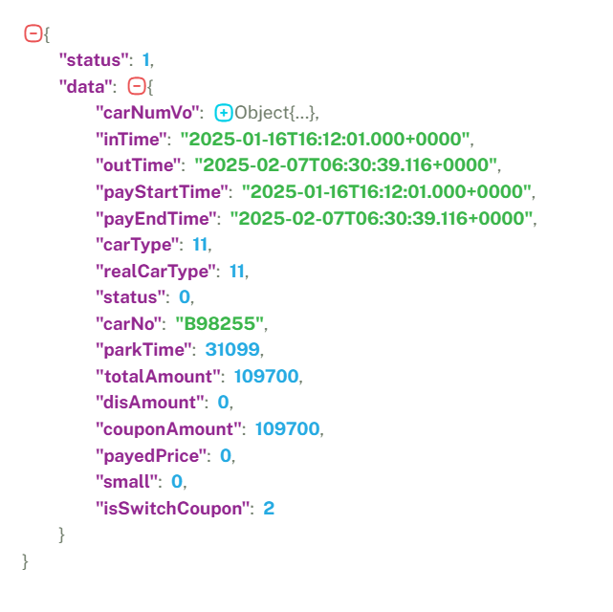

Two Lift the rod instruct
Lift the rod instruct
POST: http://192.168.1.169:9001/yard/third/openGate
Request data type:application/json | Response data type:application/json

Interface description
Interface for import and export to send bid-raising instructions

Request parameters
Parameter name | Parameter description | Type of request | Is it required | Data type
carNo | License plate number | Query | No | String
channelMac | Equipment mac address | Query | Yes | String
type | Lifting rod command [0: open the gate; 1: close the gate] | Query | Yes | Int

Response status

condition code | explain
200 | Request successful
Other status codes | Request failed, please contact:13066858850

Response parameters
Parameter name | Parameter description | Data type
status | Returned status code | Int
msg | Return message | String

Examples of response

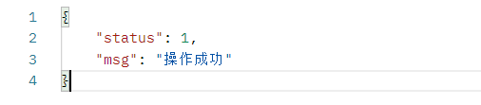
Three License plate issuance
License plate issuance
POST: http://192.168.1.169:9001/yard/third/monthRental
Request data type:application/json | Response data type:application/json

Interface description
Interfaces for issuing monthly car rental, free cars, etc.

Example of request
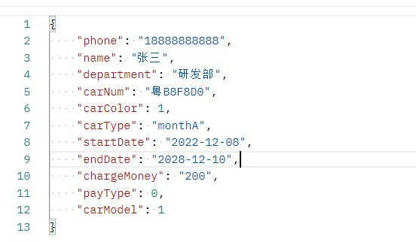

Request parameters
Parameter name | Parameter description | Type of request | Is it required | Data type
phone | Mobile phone number | Body | Yes | String
name | Full name | Body | Yes | String
department | Department | Body | Yes | String
carNum | License plate number | Body | Yes | String
carColor | License plate color type [0: unknown color; 1: white characters on blue background; 2: black characters on yellow background; 3: white characters on black background; 4: black characters on white background; 5: red characters on black background; 6: red characters on white background; 7: white characters on red background; 8: white characters on green background] | Body | No | Int
carType | Vehicle type [MonthA,MonthB,MonthC,MonthD] | Body | Yes | String
startDate | Release Date [Time Format: 2022-01-01] | Body | Yes | String
endDate | Deadline [Time Format: 2028-01-01] | Body | Yes | String
chargeMoney | Issuance amount [unit: points] | Body | Yes | String
payType | Payment method [Support method 0: Cash;1: WeChat; 2: Alipay; 3: Other] | Body | Yes | String
carModel | Issuance mode [1: monthly rent; 2: quarterly rent; 3: half-year rent; 4: annual rent] | Body | Yes | String

Response status
condition code | explain
200 | Request successful
Other status codes | Request failed, please contact:13066858850

Response parameters
Parameter name | Parameter description | Data type
status | Returned status code | Int
msg | Return message | String

Examples of response
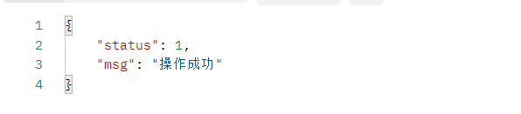
Four Palpitate
Palpitate
POST: http://192.168.1.169:9001/yard/third/heartbeat
Request data type:application/json | Response data type:application/json

Interface description
Scope: Applicable to the self-service payment machine to perform a heartbeat access verification after changing (changing) the specified cloud service address.
Function: The cloud service address currently configured for fault tolerance can work normally and perform fault tolerance for subsequent main functional interfaces.

Request parameters
No need to request parameters, just request directly.

Response status
condition code | explain
200 | Request successful
Other status codes | Request failed, please contact:13066858850

Response parameters
Parameter name | Parameter description | Data type
status | Returned status code | Int
data | The specific data returned | String

Examples of response
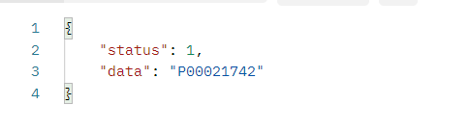

Five License plate cancellation
License plate cancellation
POST: http://192.168.1.169:9001/yard/third/monthCancel
Request data type:application/json | Response data type:application/json

Interface description
An interface for deregistering a license plate

Example of request
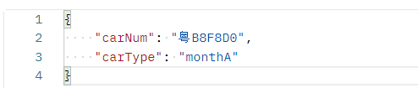

Request parameters
Parameter name | Parameter description | Type of request | Is it required | Data type
carNum | License plate number | Body | Yes | String
carType | Vehicle type [MonthA,MonthB,MonthC,MonthD] | Body | Yes | String
Response status
condition code | explain
200 | Request successful
Other status codes | Request failed, please contact:13066858850

Response parameters
Parameter name | Parameter description | Data type
status | Returned status code | Int
data | The specific data returned | String

Examples of response
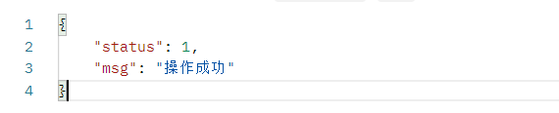

Six Parking space inquiry
Parking space inquiry
POST: http://192.168.1.169:9001/yard/third/getCarPlace
Request data type:application/json | Response data type:application/json

Interface description
Used for parking space inquiry
Request parameters
No need to request parameters, just request directly.

Response status
condition code | explain
200 | Request successful
Other status codes | Request failed, please contact:13066858850

Response parameters
Parameter name | Parameter description | Data type
status | Returned status code | Int
data | The specific data returned | String
totalPlace | Total parking spaces | Int
emptyCar | Empty parking space | Int
monthCar | Remaining parking spaces of the fixed vehicle parking lot | Int
tempCar | Remaining parking spaces for temporary vehicles | Int
orderNum | Reserve parking space | Int

Examples of response
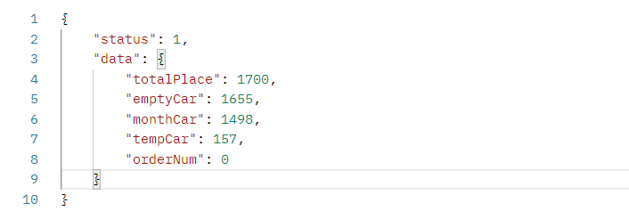
Seven Similar license plate query
Similar license plate query
POST: http://192.168.1.169:9001/yard/third/findsimilarCar?carNo=DFG0
Request data type:application/json | Response data type:application/json

Interface description
All similar license plate number information used to query the specified content from the parking lot service

Request parameters
Parameter name | Parameter description | Type of request | Is it required | Data type
carNum | License plate number | Query | Yes | String

Response status
condition code | explain
200 | Request successful
Other status codes | Request failed, please contact:13066858850

Response parameters
Parameter name | Parameter description | Data type
status | Returned status code | Int
dataList. | The specific data returned | String
Id | Id | Long
uuid | uuid | String
createTime | Creation Date | String
isLoad | Has it been uploaded (0. Not uploaded, 1. Uploaded successfully) | Int
pageNum | Current page | Int
pageSize | Number of items displayed per page | Int
CarNo | License plate number | String
carColor | Vehicle license plate color | Int
carType | Vehicle type | Int
time | Entry time | String
enterWay | Entry methods (1. Normal identification 2. Scan code entry 3. Manual entry 4. Paper ticket entry, 6. Computer gate opening) | Int
enterPass | Entrance passage | String
shortCarNum | Short license plate | String
enterUser | Entrance operator | String
small | 0 Large parking lot 1 Small parking lot | Int
inOut | 0 Entry Record 1 Exit Record | Int
isLock | 1 - Lock the car | Int
isLoadIn | Entry record upload - 1 - Success | Int
trafficChargeUpload | 1 - Successful upload of toll data to the traffic police platform | Int

Examples of response
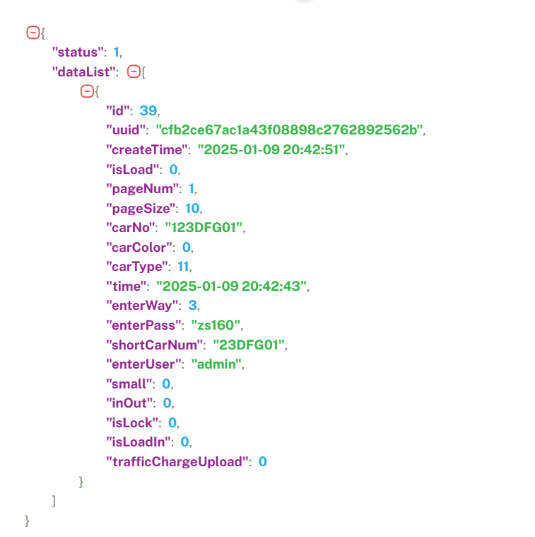
VIII Obtain the admission record
Get the admission record
POST: http://192.168.1.169:9001/yard/third/getCarIn
Request data type:application/json | Response data type:application/json

Interface description
Interface used to obtain admission records

Example of request
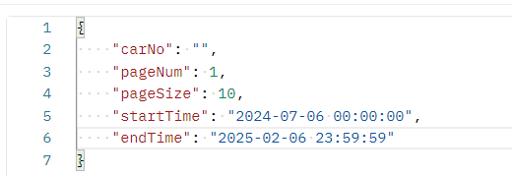

Request parameters
Parameter name | Parameter description | Type of request | Is it required | Data type
carNo | License plate number | Body | No | String
pageNum | Query the number of pages | Body | Yes | Int
pageSize | Query the number of bars per page | Body | No | Int
startTime | Check the start time | Body | No | String
endTime | Query the end time | Body | Yes | String

Response status
condition code | explain
200 | Request successful
Other status codes | Request failed, please contact:13066858850

Response parameters
Parameter name | Parameter description | Data type
status | Returned status code | Int
data | The specific data returned | String
Id | Id | Long
uuid | uuid | String
modifyTime | Modification time | String
isLoad | Has it been uploaded (0. Not uploaded, 1. Uploaded successfully) | Int
pageNum | Current page | Int
pageSize | Number of items displayed per page | Int
CarNo | License plate number | String
carType | Vehicle type | Int
time | Entry time | String
enterPass | Entrance passage | String
shortCarNum | Short license plate | String
enterUser | Entrance operator | String
small | 0 Large parking lot 1 Small parking lot | Int
inOut | 0 Entry Record 1 Exit Record | Int
isLock | 1 - Lock the car | Int
isLoadIn | Entry record upload - 1 - Success | Int
trafficChargeUpload | 1 - Successful upload of toll data to the traffic police platform | Int

Examples of response
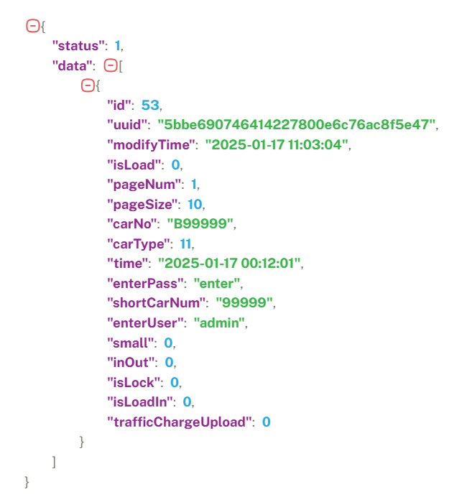
Nine Get the appearance record
Get the appearance record
POST: Http://192.168.1.169:9001/yard/third/getCarOut
Request data type:application/json | Response data type:application/json

Interface description
The interface used to obtain appearance records

Example of request
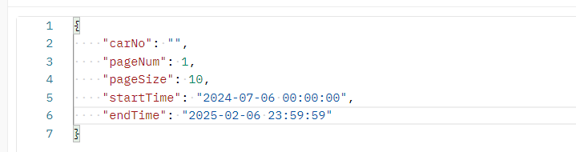

Request parameters
Parameter name | Parameter description | Type of request | Is it required? | Data type
carNo | License plate number | Body | No | String
pageNum | Query the number of pages | Body | Yes | Int
pageSize | Query the number of bars per page | Body | No | Int
startTime | Check the start time | Body | No | String
endTime | Query the end time | Body | Yes | String

Response status
condition code | explain
200 | Request successful
Other status codes | Request failed, please contact:13066858850

Response parameters
Parameter name | Parameter description | Data type
status | Returned status code | Int
data | The specific data returned | String
Id | Id | Long
uuid | uuid | String
createTime | Creation Date | String
modifyTime | Modification time | String
isLoad | Has it been uploaded(0. Not uploaded, 1. Uploaded successfully) | Int
pageNum | Current page | Int
pageSize | Number of items displayed per page | Int
carType | Vehicle type | Int
time | Entry time | String
lTime | Appearance time | String
enterWay | Entry methods (1. Normal identification 2. Scan code entry 3. Manual entry 4. Paper ticket entry, 6. Computer gate opening) | Int
leaveWay | Entry methods (1. Normal recognition 2. Scanning for entry 3. Manual confirmation 4. Paper ticket entry 5. No record entry 6. Computer gate opening) | Int
enterPass | Entrance passage | String
leavePass | Appearance passage | String
receivableFee | Amount Due | Int
fee | Actual Receipt Amount | Int
discountAmount | Discount amount | Int
paymentWay | Payment method | Int
enterUser | Entrance operator | String
leaveUser | On-site operator | String
small | 0 Large parking lot 1 Small parking lot | Int
inOut | 0 Entry Record 1 Exit Record | Int
isLock | 1 - Lock the car | Int
isLoadIn | Entry record upload - 1 - Success | Int
trafficChargeUpload | 1 - Successful upload of toll data to the traffic police platform | Int
card | Card number | String

Examples of response
{
"status": 1,
"data": [
{
"id": 36,
"uuid": "78707403522740d2a74651c4706209d7",
"createTime": "2025-01-02 15:50:45",
"modifyTime": "2025-01-17 10:00:34",
"isLoad": 0,
"pageNum": 1,
"pageSize": 10,
"carType": 31,
"time": "2025-01-02 15:50:45",
"lTime": "2025-01-17 10:00:33",
"enterWay": 1,
"leaveWay": 1,
"enterPass": "入口",
"leavePass": "出口",
"receivableFee": 0,
"fee": 0,
"discountAmount": 0,
"paymentWay": 0,
"enterUser": "admin",
"leaveUser": "admin",
"small": 0,
"inOut": 1,
"isLock": 0,
"isLoadIn": 0,
"trafficChargeUpload": 0,
"card": "0006267856",
"ltime": "2025-01-17T02:00:33.000+0000"
}
]
}

Ten GetCharge details
Get the charge details
POST: http://192.168.1.169:9001/yard/third/getChargeInfo
Request data type:application/json | Response data type:application/json

Interface description
Interface used to obtain charge details

Example of request
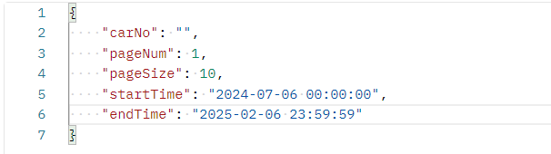
Request parameters
Parameter name | Parameter description | Type of request | Is it required | Data type
carNo | License plate number | Body | No | String
pageNum | Query the number of pages | Body | Yes | Int
pageSize | Query the number of bars per page | Body | No | Int
startTime | Check the start time | Body | No | String
endTime | Query the end time | Body | Yes | String

Response status
condition code | explain
200 | Request successful
Other status codes | Request failed, please contact:13066858850

Response parameters
Parameter name | Parameter description | Data type
status | Returned status code | Int
data | The specific data returned | String
Id | Id | Long
uuid | uuid | String
isLoad | Has it been uploaded (0. Not uploaded, 1. Uploaded successfully) | Int
pageNum | Current page | Int
pageSize | Number of items displayed per page | Int
associateId | Associated UUID | String
CarNo | License plate number | String
carRealType | Actual vehicle type | Int
carType | Vehicle type | Int
enterTime | Entry time | String
leaveTime | Appearance time | String
receivableFeeExcel | Export of Receivable Amounts | float
receivableFee | Amount Due | Int
feeExcel | Export of actual received amount | float
fee | Actual Receipt Amount | Int
discountAmountExcel | Export of discount amount | float
discountAmount | Discount amount | Int
chargePersonnel | Toll collector | String
time | Operation time | String
status | Payment status (0. Unpaid 1. Payment successful 2. Payment failed) | String
operType | Payment type: For monthly membership recharge cards (0. Account opening, 1. Extension, 2. Payment, 3. Account cancellation) | Int
payType | Payment method: 0 - Cash payment | Int
isFree | Is it free (0. Not free, 1. Free available) | Int
recordType | 0-month rental record 1- Temporary payment record | Int
billStatus | 1 - Unissued invoice; 2 - Issued invoice | Int

Examples of response
{
"Status": 1,
"Data": [
{
"Id": 2,
"Uuid": "Cec784cb86304c749008cdce4897f768",
"IsLoad": 0,
"PageNum": 1,
"Page Size": Ten,
"AssociateId": "35bde6a047ab47e4a6f3239bc8ca09d7",
"CarNum": "Guangdong B34943",
"CarRealType": 11,
"Car Type": 11,
"EnterTime": "12/25/2024 16:31:30",
"Leave Time": "12/25/2024 19:55:52",
"ReceivableFeeExcel": 0,
"Receivable Fee": 1000,
"FeeExcel": 0,
"Fee": 1000,
"DiscountAmount Excel": 0,
"Discount Amount": 0,
"ChargePersonnel": "Admin",
"Time": "12/25/2024 19:55:52",
"Status": "One",
"operType": 2,
"Pay Type": 0,
"IsFree": 0,
"Record Type": 1,
"TrafficUploadStatus": 0,
"Bill Status": 1
}
]
}

Eleven GetPictures of entry and exit
Get pictures of entry and exit
POST:http://192.168.1.169:9001/yard/third/find?CarNumUid=1137f654c0814ea4b3cd042823eb82d1
Request data type:application/json | Response data type:application/json

Interface description
The interface used to obtain entry and exit pictures

Request parameters
Parameter name | Parameter description | Type of request | Is it required | Data type
carNumUid | Unique identification of license plate number | Query | Yes | String

Response status
condition code | explain
200 | Request successful
Other status codes | Request failed, please contact:13066858850

Response parameters
Parameter name | Parameter description | Data type
status | Returned status code | Int
dataList | The specific data returned | String
Id | Id | Long
uuid | uuid | String
isLoad | Has it been uploaded? (0. Not uploaded, 1. Uploaded successfully) | Int
pageNum | Current page | Int
pageSize | Number of items displayed per page | Int
carNumId | Association of Entry and Exit Lists | String
relativePath | The relative path of the file stored on the server | String
carNumType | 0. Main camera image of entrance, 1. Small main camera image of entrance, 2. Main camera image of exit, 3. Small main camera image of exit, 4. Main camera image of exit, 5. Small main camera image of exit, 6. Main camera image of exit, 7. Small main camera image of exit | Int
time | Upload time | String

Examples of response
{
"Status": 1,
"Data List": [
{
"Id": 103,
"Uuid": "Afbb4d4ebf9c46ad91cf390d9a18c273",
"IsLoad": 0,
"PageNum": 1,
"Page Size": Ten,
"CarNumId": "1137f654c0814ea4b3cd042823eb82d1",
"Relative Path": "Images/2025/1/9/1921681160_202519204320_big.jpg",
"CarNumType": 0,
"Time": "January 9, 2025 20:43:21",
"TrafficUploadStatus": 0
}
]
}

Twelve Payment is completed and issued
Payment is completed and issued
POST: http://192.168.1.169:9001/yard/third/userPaymentCarFee
Request data type:application/json | Response data type:application/json

Interface description
Used for Complete the user's parking payment interface

Request parameters
Parameter name | Parameter description | Type of request | Is it required | Data type
carNo | License plate number | Body | Yes | String
chargeTime | Start billing time | Body | Yes | String
couponAmount | Actual amount received [unit: points] | Body | Yes | Int
disAmount | Discount amount [unit: points] | Body | Yes | Int
endChargeTime | End billing time | Body | Yes | String
mac | Channel mac address | Body | No | String
openid | WeChat openid | Body | No | String
payType | .Payment type [0: Cash; 1: WeChat; 2: Alipay] | Body | Yes | Int
totalAmount | Receivable amount [unit: point] | Body | Yes | Int
transactionId | Payment Order No (Unique Identifier) | Body | Yes | String

Response status
condition code | explain
200 | Request successful
Other status codes | Request failed, please contact:13066858850

Response parameters
Parameter name | Parameter description | Data type
status | Returned status code | Int
data | The specific data returned | String

Examples of response
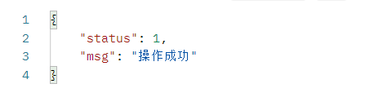

Thirteenth Vehicle accesses info at channel
Vehicle accesses info at channel
POST: http://192.168.1.169:9001/yard/third/getPushNotification?channelMac=1803001B1226
Request data type:application/json | Response data type:application/json

Interface description
Used to complete the parking payment interface for users

Request parameters
Parameter name | Parameter description | Type of request | Is it required | Data type
channelMac | Channel MAC address | query | Yes | String

Response status
condition code | explain
200 | Request successful
Other status codes | Request failed, please contact:13066858850

Response parameters
Parameter name | Parameter description | Data type
status | Returned status code | Int
data | The specific data returned | String
channelName | Channel Name | String
mac | Device MAC address | String
carNum | License plate number | String
isNoCarNo | 0 - Registered vehicle 1 - Unregistered vehicle | Int
carNumType | Vehicle license plate color | Int
time | Entry time | String
user | Operator | String

Examples of response
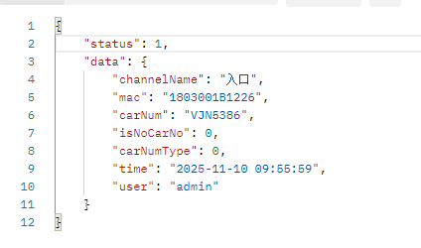

April Monthly Subscription Renewal
Monthly card recharge and renewal
POST: http://192.168.1.169:9001/yard/third/findMonthCarInfo
Request data type:application/json | Response data type:application/json

Interface description
Used for querying monthly truck information

Request parameters
Parameter name | Parameter description | Type of request | Is it required | Data type
carNum | License plate | body | Yes | String

Response status
condition code | explain
200 | Request successful
Other status codes | Request failed, please contact:13066858850

Response parameters
Parameter name | Parameter description | Data type
status | Returned status code | Int
data | The specific data returned | String
id | Auto-incrementing primary key ID of data | Int
uuid | Unique business number | String
createTime | Creation time, format: yyyy-MM-dd HH:mm:ss | String
createName | Create a user account | String
carNum | License plate number | String
carType | Vehicle type | Int
startTime | Start time, in the format yyyy-MM-dd HH:mm:ss | String
endTime | End time, format: yyyy-MM-dd HH:mm:ss | String
balanceMoney | Account balance (in units of cents) | Int
status | License plate status (0 - normal, 1 - account cancelled) | Int
payType | Payment method | Int
chargeMoney | Monthly rental fee amount (monthly rent, unit: cents) | Int

Examples of response
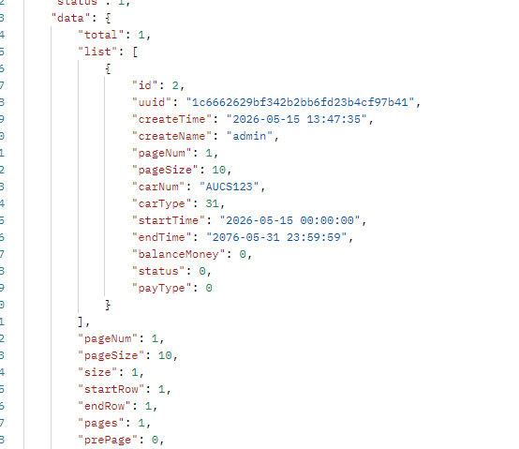

POST: http://192.168.1.169:9001/yard/third/findMonthCarInfo
Request data type:application/json | Response data type:application/json

Interface description
For monthly card renewal recharge

Request parameters
Parameter name | Parameter description | Type of request | Is it required | Data type
id | Auto-incrementing primary key ID of data | body | Yes | Int
uuid | Unique business number | body | Yes | String
createTime | Creation time, format: yyyy-MM-dd HH:mm:ss | body | Yes | String
createName | Create a user account | body | Yes | String
carNum | License plate number | body | Yes | String
carType | Vehicle type | body | Yes | Int
startTime | Start time, in the format yyyy-MM-dd HH:mm:ss | body | Yes | String
endTime | End time, format: yyyy-MM-dd HH:mm:ss | body | Yes | String
balanceMoney | Account balance (in units of cents) | body | Yes | Int
status | License plate status (0 - normal, 1 - account cancelled) | body | Yes | Int
delayMoney | Renewal fee amount (unit: cents) | body | Yes | Int
operType | Operation Type (1, Monthly Rental 2, Prepaid Vehicle) | body | Yes | Int
payType | Payment method (0: Cash payment, 1: WeChat, 2: Alipay) | body | Yes | Int
chargeMoney | Monthly rental fee amount (monthly rent, unit: cents) | body | Yes | Int

Response status
condition code | explain
200 | Request successful
Other status codes | Request failed, please contact:13066858850

Response parameters
Parameter name | Parameter description | Data type
status | Returned status code | Int
msg | The specific data returned | String

Examples of response
